UoT Solar Fuels Team

STEPS TOWARD A SUSTAINABLE FUTURE
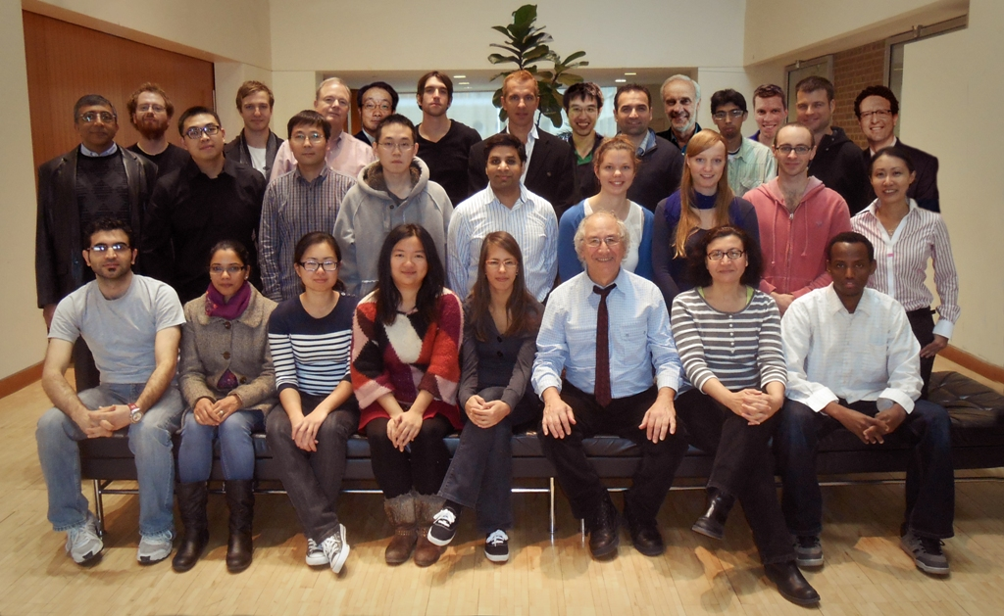

Clean, renewable, energy-generating methods that produce electricity from the sun and wind suffer from the problem of intermittency as well as the difficulty of storing electricity, as it has to be used essentially as it is produced. Hence there exists an urgent need to find a way of producing energy-rich fuels that can be transported and stored for use on demand.

A silver bullet solution to this important problem is to discover high efficiency photo-catalytic materials and processes that can make solar fuels, such as methanol or methane, from sunlight. In this context, our program of solar fuels research is aimed at harnessing solar energy to make an energy rich portable fuel by artificial photosynthesis, in essence, mimicking Nature’s biological photosynthetic leaf. It is inspired by our belief that the long term use of fossil fuels is not sustainable or practical.

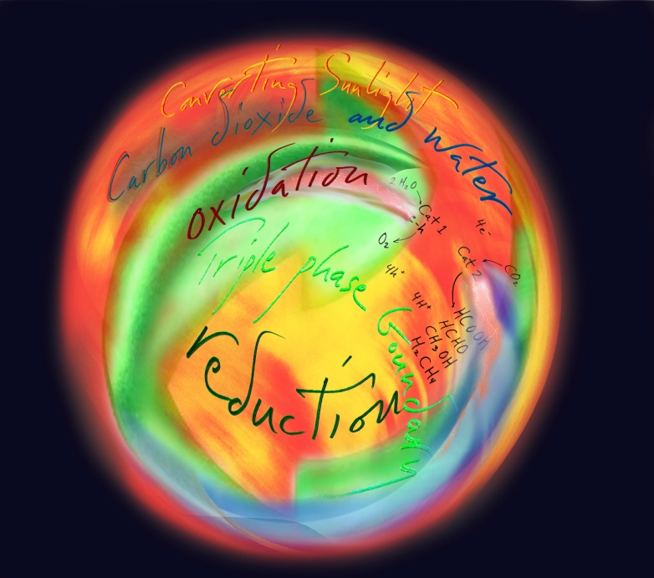
In this context, we support the argument that the rush to develop bio-fuels is short-sighted. Evidence is growing that its production, by any means, has a poor energy balance and does not lead to any appreciable reduction of carbon dioxide emissions that could be better achieved by modest energy conservation. Moreover, with a population increase of about 75 million per year, bio-fuels are a regrettable misuse of land and water resources sorely needed to maintain the earth’s growing population. There is also a debate whether carbon capture and storage should be implemented to achieve climate change targets. Arguments against carbon capture and storage is that it is a largely untested technology with health and safety concerns, it is energy intensive to apply and it will raise the cost of electricity, so much so that a renewable energy infrastructure could be developed quicker and cheaper.
Solar Fuels from the Sun not Fossil Fuels from the Earth - Todd Siler and Geoffrey Ozin, ArtNano Innovations© 2013.
It is our view that a longer term investment in artificial photosynthesis research and development aimed at solar fuels, rather than the shorter term focus on bio-fuels and carbon capture and storage, presents a more practical solution to the intertwined climate change and sustainable energy challenges facing society today. Like photovoltaic devices that generate electricity from the sun, solar fuel devices that make fuel from the sun can be deployed on non-arable land. We believe that once the scientific and technical hurdles of artificial photosynthesis have been understood and surmounted, through strong and sustained solar fuels research over the next 5 years, then a global artificial photosynthesis strategic plan can be implemented to provide a lower cost and more sustainable green fuel, offering genuine rather than misplaced benefits promised by bio-fuels and carbon capture and storage.

The Intergovernmental Panel on Climate Change, October 2013, reported that it is 95% certain humans are the cause of anthropogenic climate change. It is now more urgent than ever before that government, industry and business stakeholders invest in long-term research on artificial photosynthesis, which promises a new CO₂ economy and a new era of sustainability by gifting humanity with an unlimited supply of carbon neutral solar fuels from the sun rather than depleting the finite source of legacy fossil fuels from the earth and replacing them with increasing amounts of greenhouse gas in the atmosphere!

Since the inauguration of our project on Solar Fuels at the University of Toronto, the Solar Fuels research team has made significant strides towards artificial photosynthesis materials, which can mimic the production of energy rich fuels by biological photosynthesis. This process means, both fuel generation using (free) sunlight, and carbon dioxide capture (to reduce global climate levels), and represents a scientific and technological ‘holy grail’. Towards this end, great progress has been facilitated by our interdisciplinary team’s ability to ramp-up capacity to synthesize, structurally characterize and measure key properties of artificial photosynthesis materials (Chemistry) and to reduce the bottleneck to gas and aqueous phase photo-catalyst testing with rapid sample throughput, by the addition of advanced photo-reactors integrated with on-line, state-of-the-art gas chromatography and mass spectroscopy (Chemical Engineering). A further thrust has been in high performance computational simulation, high end electron microscopy, and integrated device design for studying solar fuels materials (Materials Science).

To be technologically significant and cost effective, artificial photosynthesis needs to achieve at least a thousand times improvement in conversion rates and efficiencies above current levels for these sunlight-powered reactions. A great deal of progress has been made by this team towards identifying the chemical and physical attributes of this x1000 challenge. With this knowledge, the solar fuels team is rising to the x1000 challenge with the synthesis of an expanded and enriched portfolio of solar fuels materials, whose structures, electronic and optical properties have been determined and geared towards the attainment of a high performance photo-catalyst. By selecting the most interesting materials in the solar fuels portfolio, we have achieved some very promising results from gas and aqueous phase photo-catalytic and photo-electrochemical testing.

Another project objective is a techno-economic analysis of a plug-and-play solar fuels system that can be integrated with a natural gas powered electricity generating plant. Our preliminary results provide an estimate of the cost (per square meter) of 10% efficient solar fuels panels covering an area of 1 km² required to power a zero-emission, carbon-neutral, natural gas powered electricity generating plant. Steps have also been undertaken towards the identification of potential strategic partners who could enable commercialization of solar fuels zero-emission farms, houses, buildings and power plants in the event of a technologically significant materials breakthrough.

This project requires the synergistic integration of a wide range of science and engineering fields and skill-sets. To this end, the Solar Fuels team leader, Geoff Ozin, has assembled a unique team of world-class expertise at U of T, which includes know-how from chemistry, chemical engineering, materials science, climate science and economics, law and business, across campus and beyond. We now have the required expertise and momentum to transition this research towards practical artificial photosynthetic materials, devices and processes in the coming years.

